**DAILY ONLINE ACTIVITIES SUMMARY**

|  |  |  |  |  |  |  |  |  |
| --- | --- | --- | --- | --- | --- | --- | --- | --- |
| **Date:** | **21/05/2020** | | | | | **Name:** | **SPOORTI S DAROJI** | |
| **Sem & Sec** | **4th SEM. & ‘B’ SEC.** | | | | | **USN:** | **4AL18CS088** | |
| **Online Test Summary** | | | | | | | | |
| **Subject** | | **MICROCONTROLLER AND EMBEDDED SYSTEM** | | | | | | |
| **Max. Marks** | | **30** | | **Score** | | | **21** | |
| **Certification Course Summary** | | | | | | | | |
| **Course** | **Python for Machine Learning** | | | | | | | |
| **Certificate Provider** | | | **Greatlearning**  **academy** | | **Duration** | | | **5 Hrs.** |
| **Coding Challenges** | | | | | | | | |
| **Problem Statement 1:** [**Write a C Program to**](https://github.com/orgs/alvas-education-foundation/teams/2nd-year/discussions/67) **implement SRTF process scheduling.**  **Input:A set of processes with their burst time and arrival time.**  **Problem Statement 2:**  **Write a C program to construct a SLL by removing duplicate elements in sorted linked list**  **Description:Take a sorted list and traverse the list. Compare the current node element with the next adjacent node. If it is the same then delete the second element, if not retain. Finally print the resulting list.**  **Sample output:**  **Given list {1,2,2,3,3,3,4}**  **Resulting list{1,2,3,4}** | | | | | | | | |
| **Status: Executed.** | | | | | | | | |
| **Uploaded the report in Github** | | | | | **Yes** | | | |
| **If yes Repository name** | | | | | [alvas-education-foundation](https://github.com/alvas-education-foundation)/[spoorti_daroji](https://github.com/alvas-education-foundation/spoorti_daroji) | | | |
| **Uploaded the report in slack** | | | | | **Yes** | | | |

**Online Test Summary: 18CS44 test was scheduled from 10:00AM to 10:30AM.The Portion was for the IA was 1st module there were 30 questions & the time assigned was 30 minutes. The questions were mcq type.**

**Online Certification course Summary: In today’s session I have learnt about Data Structures in python.**

**Lists**

* **A list can store a sequence of objects.**
* **These objects can be of various types.**
* **List is created by square brackets.**

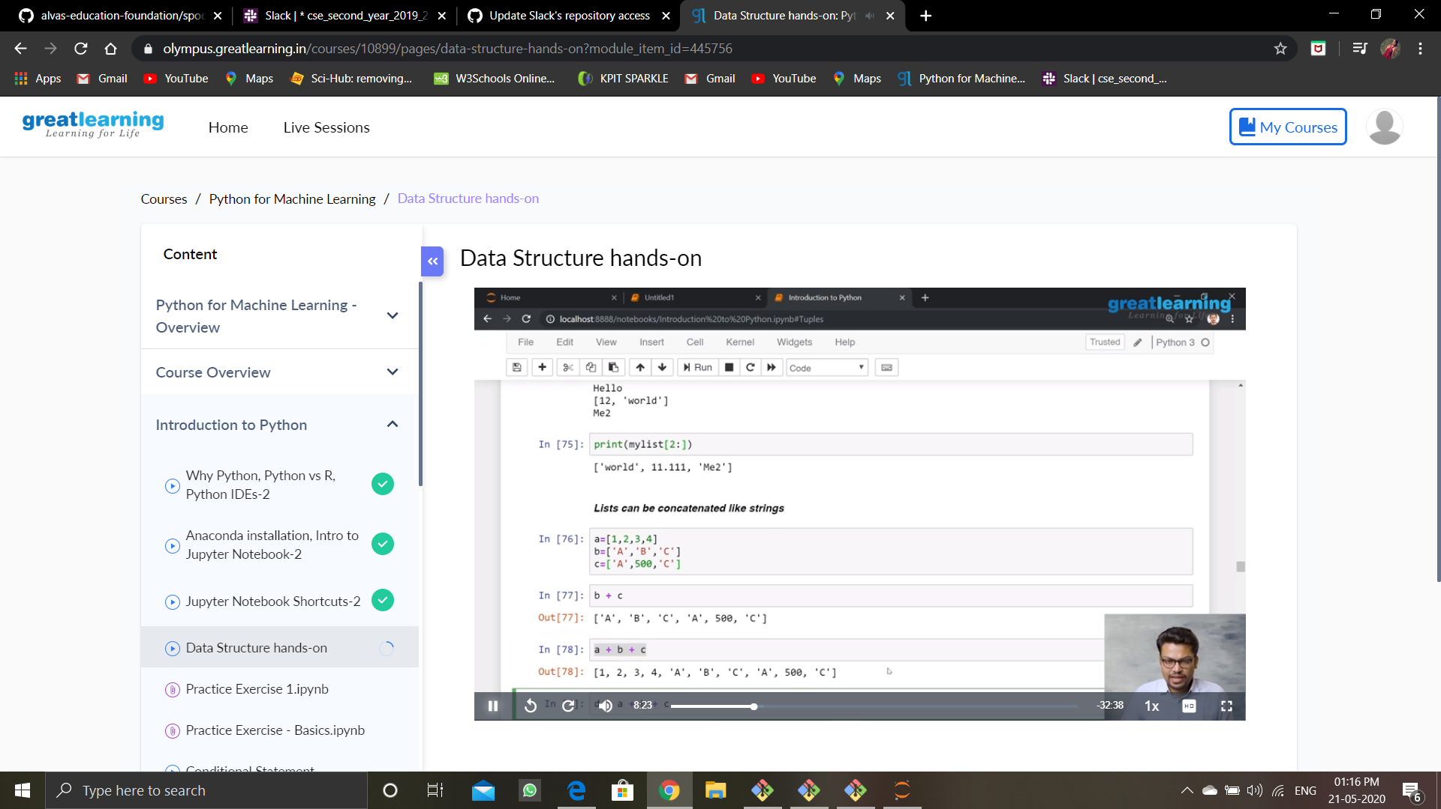

**I had gone through some examples where I learnt how lists are used in python.where mylist([1:3]) says that 1 means start of the index and 3 means 3rd index of list, and mylist[-1] implies last element stored in the string. And list holds the properties of strings which means concatenation and other properties, which can be done easily in python.As shown in the snapshot below.**

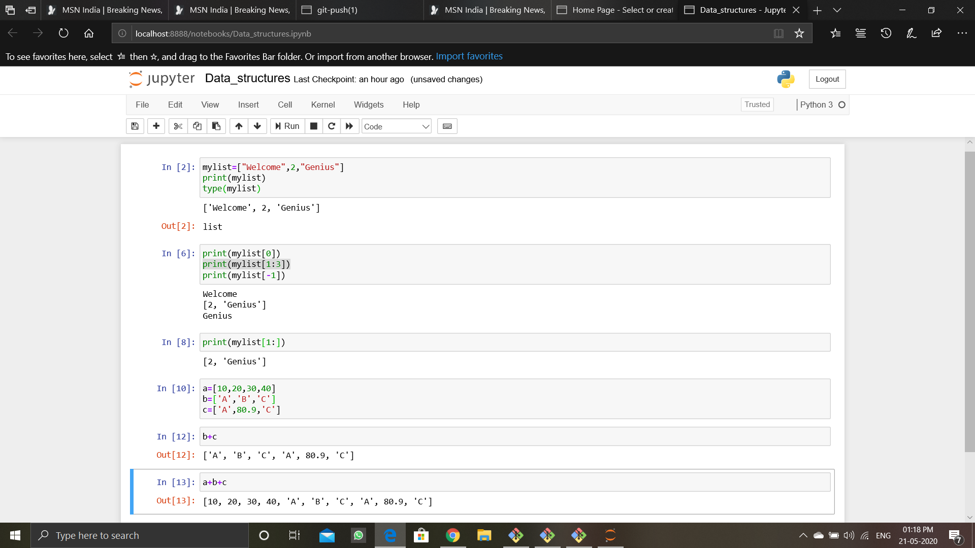

**Online Coding Summary: Today I received the first program from prof.Merlyn Mathias CSE Dept, second program was given by prof.Harshitha GM CSE Dept .**

**The programs are mentioned above in the coding challenges.I have written programs and uploaded it to my Github repository.**

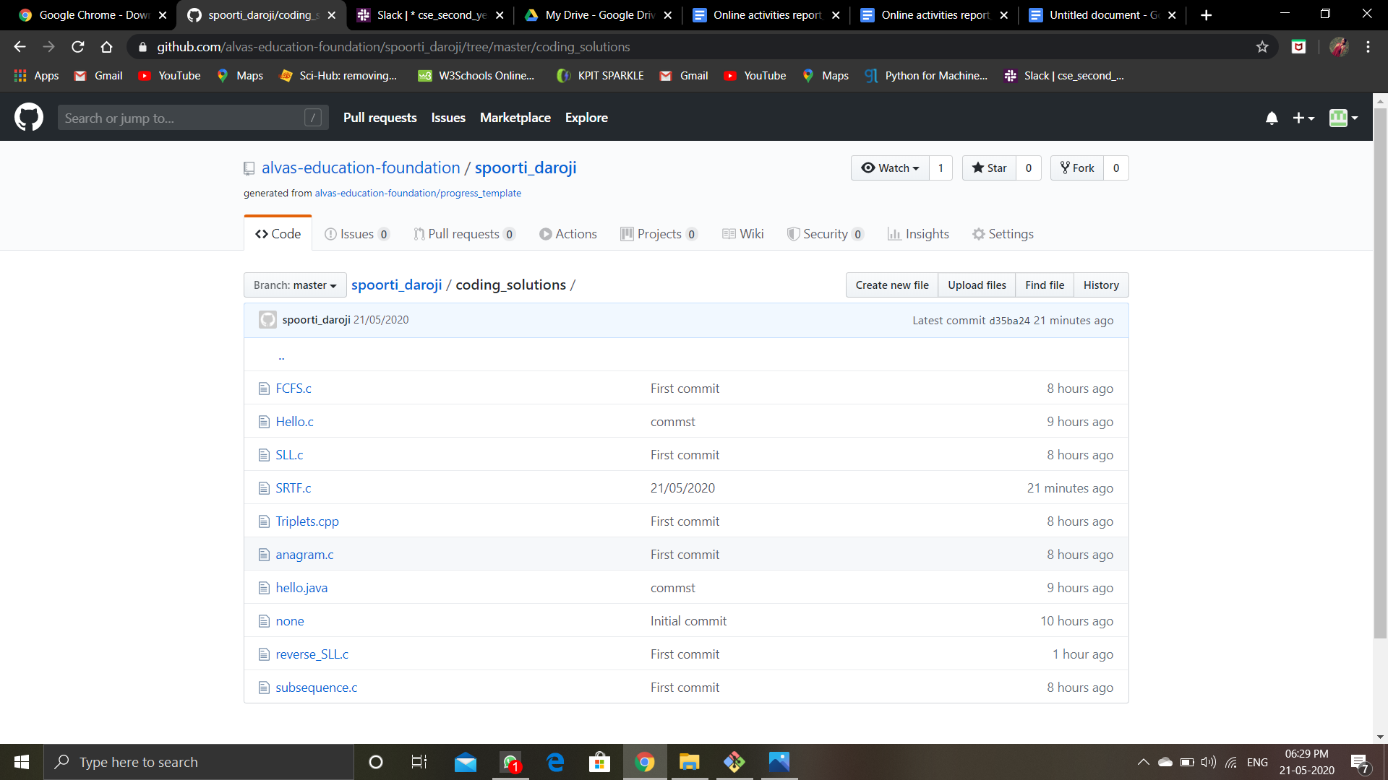

**It is the snapshot of my repository were i have uploaded the code.file name is reverse_SLL.c and SRTF.c**